Lab 06 – Worksheet
Name: Shaheer Qureshi, Areeba Izhar | ID: sq09647, ao09625 | Section: T1

Note: Assumptions and logics should be explained separately in tasks after the task results.

Task 1
Block Diagrams

Comments

Task 2
Modules + Testbench:
Sources:-
1.
`timescale 1ns / 1ps
module alu_top (
input wire clk,
input wire pbin, // Reset button
input wire [15:0] physical_sw, // FPGA Switches
output wire [15:0] physical_leds // FPGA LEDs
);
wire rst_clean;
debouncer rst_db (.clk(clk), .pbin(pbin), .pbout(rst_clean));
wire [31:0] switch_data;
leds switch_reader (
.clk(clk), .rst(rst_clean), .btns(16'd0), .writeData(32'd0),
.writeEnable(1'b0), .readEnable(1'b1), .memAddress(30'd0),
.switches(physical_sw), .readData(switch_data)
);
reg [31:0] led_write_data = 32'd0;
switches led_writer (
.clk(clk), .rst(rst_clean), .writeData(led_write_data),
.writeEnable(1'b1), .readEnable(1'b0), .memAddress(30'd0),
.readData(), .leds(physical_leds)
);
wire [31:0] fixed_A = 32'h10101010;
wire [31:0] fixed_B = 32'h01010101;
reg [3:0] current_alu_ctrl;
wire [31:0] alu_result;
wire alu_zero;
alu_32bit ALU_Inst (
.A(fixed_A),
.B(fixed_B),
.ALUControl(current_alu_ctrl),
.ALUResult(alu_result),
.Zero(alu_zero)
);
localparam READ_INPUTS = 1'b0;
localparam UPDATE_LEDS = 1'b1;
reg state = READ_INPUTS;
always @(posedge clk) begin
if (rst_clean) begin
state <= READ_INPUTS;
current_alu_ctrl <= 4'd0;
led_write_data <= 32'd0;
end else begin
case (state)
READ_INPUTS: begin
// Read the bottom 4 switches to select the ALU operation
current_alu_ctrl <= switch_data[3:0];
state <= UPDATE_LEDS;
end
UPDATE_LEDS: begin
// Format the LED output:
// LED 15 = Zero Flag
// LEDs 14:0 = Bottom 15 bits of the math result
led_write_data <= {16'd0, alu_zero, alu_result[14:0]};
state <= READ_INPUTS; // Loop back
end
endcase
end
end
endmodule

2,3,4.
debouncer.v, leds.v, switches.v used from Lab05.

5.
`timescale 1ns / 1ps
module alu_32bit(
input wire [31:0] A,
input wire [31:0] B,
input wire [3:0] ALUControl,
output reg [31:0] ALUResult,
output wire Zero
);
always @(*) begin
case (ALUControl)
4'b0000: ALUResult = A & B; // AND
4'b0001: ALUResult = A | B; // OR
4'b0010: ALUResult = A + B; // ADD
4'b0110: ALUResult = A - B; // SUB
4'b0100: ALUResult = A ^ B; // XOR
4'b1000: ALUResult = A << B[4:0]; // SLL (Shift Left Logical)
4'b1001: ALUResult = A >> B[4:0]; // SRL (Shift Right Logical)
default: ALUResult = 32'd0; // Default to 0
endcase
end
assign Zero = (ALUResult == 32'd0) ? 1'b1 : 1'b0;
endmodule

6.
`timescale 1ns / 1ps
module alu_1bit (
input wire A,
input wire B,
input wire [3:0] ALUControl,
output reg ALUResult,
output wire Zero
);
always @(*) begin
case (ALUControl)
4'b0000: ALUResult = A & B; // AND
4'b0001: ALUResult = A | B; // OR
4'b0010: ALUResult = A ^ B; // ADD
4'b0110: ALUResult = A ^ B; // SUB
4'b0100: ALUResult = A ^ B; // XOR
4'b1000: ALUResult = 1'b0; // SLL
4'b1001: ALUResult = 1'b0; // SRL
default: ALUResult = 1'b0;
endcase
end

assign Zero = ~ALUResult;
endmodule

Testbench files:-
1:-
`timescale 1ns / 1ps
module alu_1bit_tb;
// Inputs
reg A;
reg B;
reg [3:0] ALUControl;
// Outputs
wire ALUResult;
wire Zero;
// Instantiate the Unit Under Test (UUT)
alu_1bit uut (
.A(A),
.B(B),
.ALUControl(ALUControl),
.ALUResult(ALUResult),
.Zero(Zero)
);
initial begin
// Initialize Inputs
A = 0;
B = 0;
ALUControl = 0;
// Wait 10 ns for global reset to finish
#10;
// Print header for the console output
// Test 1: AND
ALUControl = 4'b0000; A = 1'b1; B = 1'b1; #10;
ALUControl = 4'b0000; A = 1'b1; B = 1'b0; #10;
// Test 2: OR
ALUControl = 4'b0001; A = 1'b0; B = 1'b1; #10;
ALUControl = 4'b0001; A = 1'b0; B = 1'b0; #10;
// Test 3: ADD (Acts as XOR in this dataless 1-bit version)
ALUControl = 4'b0010; A = 1'b1; B = 1'b0; #10;
ALUControl = 4'b0010; A = 1'b1; B = 1'b1; #10; // Result should be 0, Zero flag 1
// Test 4: SUB (Acts as XOR)
ALUControl = 4'b0110; A = 1'b1; B = 1'b1; #10; // Result should be 0, Zero flag 1
ALUControl = 4'b0110; A = 1'b0; B = 1'b1; #10;
// Test 5: XOR
ALUControl = 4'b0100; A = 1'b1; B = 1'b0; #10;
// Test 6: SLL (Expected to output 0 as per our 1-bit module)
ALUControl = 4'b1000; A = 1'b1; B = 1'b1; #10;
// Test 7: SRL (Expected to output 0)
ALUControl = 4'b1001; A = 1'b1; B = 1'b0; #10;
// End simulation
#10;
$finish;
end
endmodule

2:-
`timescale 1ns / 1ps
module alu_32bit_tb;
// Inputs
reg [31:0] A;
reg [31:0] B;
reg [3:0] ALUControl;
// Outputs
wire [31:0] ALUResult;
wire Zero;
// Instantiate the Unit Under Test (UUT)
alu_32bit uut (
.A(A),
.B(B),
.ALUControl(ALUControl),
.ALUResult(ALUResult),
.Zero(Zero)
);
initial begin
// Initialize Inputs
A = 0;
B = 0;
ALUControl = 0;
// Wait 100 ns for global reset to finish
#100;
// Test 1: ADD
A = 32'd250;
B = 32'd150;
ALUControl = 4'b0010; // ADD
#10;
// Test 2: SUB
A = 32'd500;
B = 32'd500;
ALUControl = 4'b0110; // SUB
#10;
// Test 3: AND
A = 32'hFFFF_0000;
B = 32'hFF00_FF00;
ALUControl = 4'b0000; // AND
#10;
// Test 4: OR
A = 32'h0000_000F;
B = 32'h0000_00F0;
ALUControl = 4'b0001; // OR
#10;
// Test 5: XOR
A = 32'hAAAA_AAAA;
B = 32'h5555_5555;
ALUControl = 4'b0100; // XOR
#10;
// Test 6: SLL (Shift Left Logical)
A = 32'h0000_0001;
B = 32'd4; // Shift left by 4
ALUControl = 4'b1000; // SLL
#10;
// Test 7: SRL (Shift Right Logical)
A = 32'h0000_00F0;
B = 32'd4; // Shift right by 4
ALUControl = 4'b1001; // SRL
#10;
// End simulation
#10;
$finish;
end
endmodule

Results:
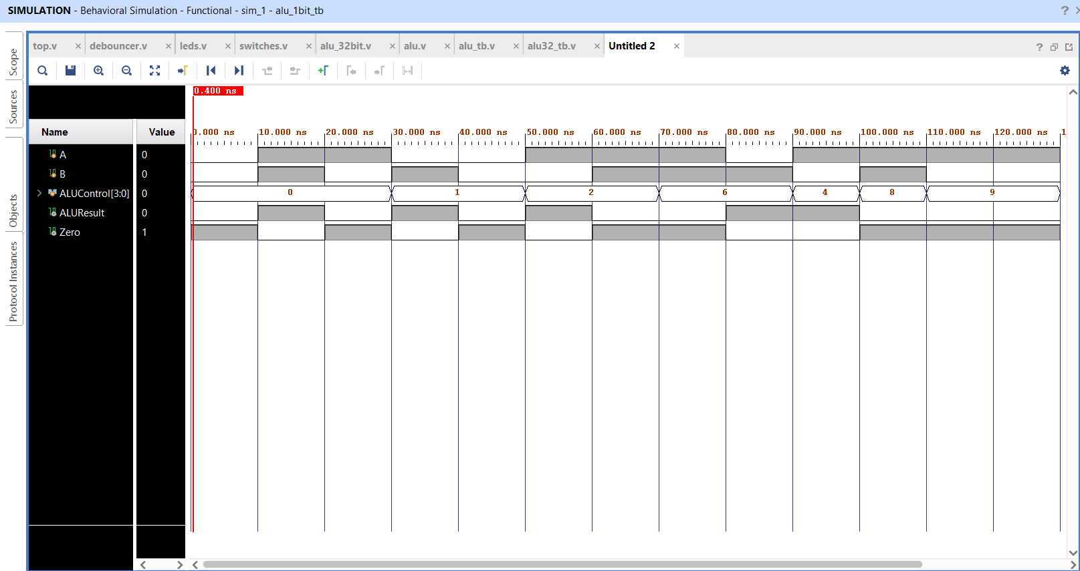
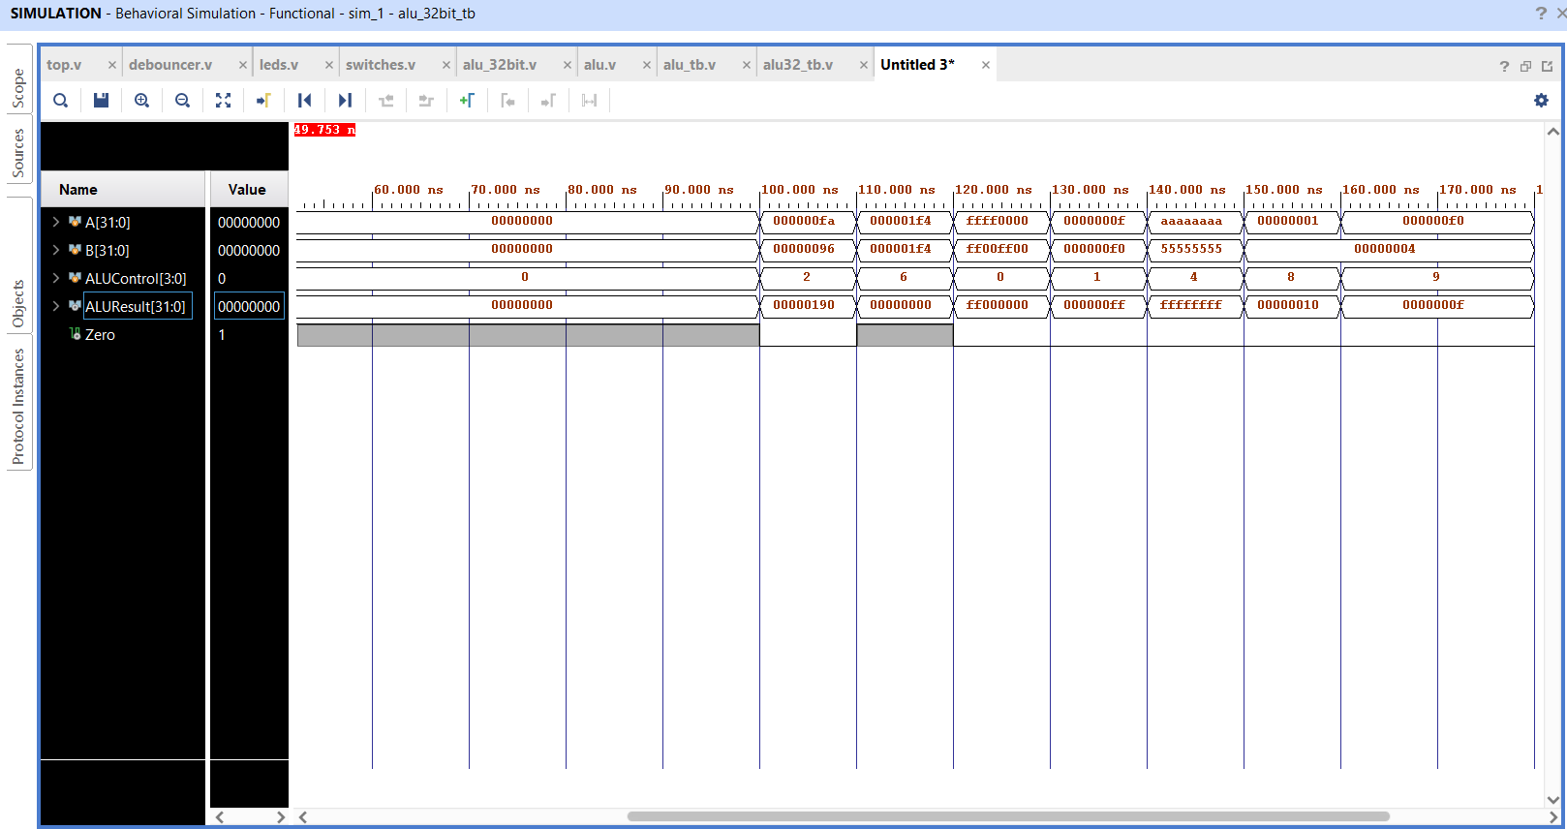

Task 3

RTL Schematics

Lab 05 – Designing FSM Using FPGA Switches and LEDs

Assessment Rubrics

Points Distribution
Task No. | LR2  Code | LR 5  Results | LR11  Design | AR7
Task 1 | - | - | /20 | /20
Task 2 | /20 | /15
Task 3 | /10 | /15
Total Points | /80 |  |  | /20
CLO Mapped | CLO 1
For description of different levels of the mapped rubrics, please refer the provided Lab Evaluation Assessment Rubrics and Affective Domain Assessment Rubrics.
# | Assessment Elements | Level 1: Unsatisfactory  Points 0-1 | Level 2: Developing  Points 2 | Level 3:Good  Points 3 | Level 4:Exemplary  Points 4
LR2 | Program/Code/ Simulation Model/ Network Model | Program/code/simulation model/network model does not implement the required functionality and has several errors. The student is not able to utilize even the basic tools of the software. | Program/code/simulation model/network model has some errors and does not produce completely accurate results. Student has limited command on the basic tools of the software. | Program/code/simulation model/network model gives correct output but not efficiently implemented or implemented by computationally complex routine. | Program/code/simulation /network model is efficiently implemented and gives correct output. Student has full command on the basic tools of the software.
LR5 | Results & Plots | Figures/ graphs / tables are not developed or are poorly constructed with erroneous results. Titles, captions, units are not mentioned. Data is presented in an obscure manner. | Figures, graphs and tables are drawn but contain errors. Titles, captions, units are not accurate. Data presentation is not too clear. | All figures, graphs, tables are correctly drawn but contain minor errors or some of the details are missing. | Figures / graphs / tables are correctly drawn and appropriate titles/captions and proper units are mentioned. Data presentation is systematic.
AR9 | Report | All the in-lab tasks are not included in report and / or the report is submitted too late. | Most of the tasks are included in report but are not well explained. All the necessary figures / plots are not included. Report is submitted after due date. | Good summary of most the in-lab tasks is included in report. The work is supported by figures and plots with explanations. The report is submitted timely. | Detailed summary of the in-lab tasks is provided. All tasks are included and explained well. Data is presented clearly including all the necessary figures, plots and tables.

